Mert Aydin 27-11-2020 Mobile Phone Bill Calculator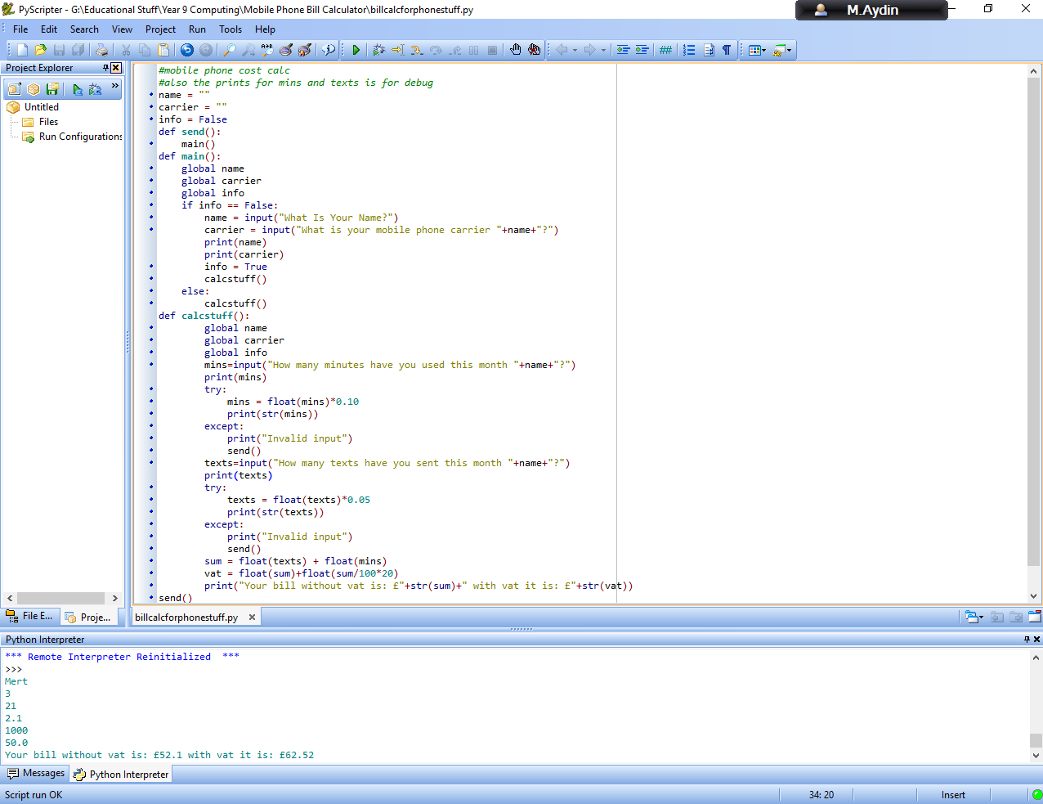

Code:

#mobile phone cost calc

#also the prints for mins and texts is for debug

name = ""

carrier = ""

info = False

def send():

main()

def main():

global name

global carrier

global info

if info == False:

name = input("What Is Your Name?")

carrier = input("What is your mobile phone carrier "+name+"?")

print(name)

print(carrier)

info = True

calcstuff()

else:

calcstuff()

def calcstuff():

global name

global carrier

global info

mins=input("How many minutes have you used this month "+name+"?")

print(mins)

try:

mins = float(mins)\*0.10

print(str(mins))

except:

print("Invalid input")

send()

texts=input("How many texts have you sent this month "+name+"?")

print(texts)

try:

texts = float(texts)\*0.05

print(str(texts))

except:

print("Invalid input")

send()

sum = float(texts) + float(mins)

vat = float(sum)+float(sum/100\*20)

print("Your bill without vat is: £"+str(sum)+" with vat it is: £"+str(vat))

send()